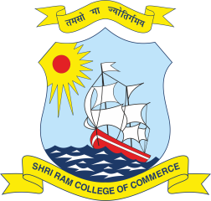
SHRI RAM COLLEGE OF COMMERCE
University of Delhi, Maurice Nagar, Delhi – 110007
Phone: 27667905, 27666519 ▪ Fax: 27666510
Website: www.srcc.edu ▪ email: srcc@srcc.edu

Date: 21.07.2020

All students, teachers and staffs of our college are hereby informed that we are starting online communication with Physiotherapist and Fitness Trainer. Schedule of program given below:
Session | Time | Resource Person
Online / recorded Sessions on Fitness* | 9:00 am to 10:00 am  Monday to Friday | Sumit Tyagi, (Physiotherapist) & Mr.Kadar Khan( Fitness Trainer)
One to one Interaction with physiotherapist & Fitness trainer (with prior appointment through e-mail) | 10:30 am to 12:30 pm | Sumit Tyagi & Kadar Khan
Lecture on any current topic of Physical fitness and Physiotherapy | 12:30 pm to 01:00 pm  (Wednesday) | Sumit Tyagi & Kadar Khan
Consultancy through Mail |  | Sumit Tyagi: physiotherapist.srcc@gmail.com  Kadar Khan: fitnesscentre.srcc@gmail.com

*Online /recorded sessions on fitness will be scheduled on google meet.

Link: https://meet.google.com/vjk-ggyp-awd

Principal

